Hierarchical Constrained Multi-Agent Reinforcement Learning for Equitable and Safe Autonomous Hospital Resource Management
Dr. D Jeya Mala
SCOPE
Soorya Kiran S Nihara Rajesh
23BPS1174 23BPS1071

Abstract—Autonomous hospital resource management systems face the critical challenge of optimizing throughput without compromising patient safety or demographic equity. Current reinforcement learning (RL) models often optimize single departments in isolation, leading to downstream bottlenecks and algorithmic bias against marginalized demographics. This paper proposes a Hierarchical Constrained Multi-Agent Reinforcement Learning (HC-MARL) framework. We are applying a model of hierarchical decentralized execution. Our architecture uses a Global Meta Agent for macro-level resource distribution and Local Agents for micro-level departmental triage (sorting and prioritizing patients based on how urgent or serious they are). To resolve the conflict between immediate clinical safety and long term fairness, the architecture employs a staged dual mechanism: a Constrained Markov Decision Process (CMDP) filter enforces hard clinical safety limits, while a mathematical equity penalty in the global reward function reduces algorithmic bias.
Index Terms—Multi-Agent Reinforcement Learning, Resource Allocation, Constrained Markov Decision Process, Algorithmic Fairness
I. Introduction
Modern healthcare systems operate under immense pressure, with dynamic patient arrivals constantly overloading finite resources. Traditional resource management relies heavily on static, heuristic based protocols or isolated predictive analytics, which struggle to adapt to sudden surges like this.
Reinforcement Learning has emerged as a promising solution for dynamic resource allocation, utilising algorithms that learn optimal policies through trial and error [1]. However, transitioning these algorithms from isolated simulations to autonomous hospital-wide deployment reveals critical blind spots.
First, hospitals are highly interconnected ecosystems; an RL agent optimizing solely for emergency room (ER) throughput may prematurely push patients to general wards, instantly shifting the bottleneck rather than resolving it. Second, standard RL objective functions maximize aggregate rewards. If trained on historically biased data, these agents maximize their scores by systematically denying resources to historically marginalized groups. Finally, the exploratory nature of RL poses severe clinical risks, as trial-and-error actions can violate fundamental patient safety thresholds.
To address these limitations, this paper introduces a Hierarchical Constrained Multi-Agent Reinforcement Learning (HC-MARL) architecture. By adapting the Constrained Markov Decision Process (CMDP) framework that is usually used to enforce physical boundaries in safety critical robotics [5] into the stochastic domain of clinical healthcare, this approach provides a deployable blueprint for autonomous healthcare management.
II. Literature Survey
Table I summarizes highly relevant and recent research in RL-driven healthcare operations and constrained learning. By analyzing these specific works, we identify the exact gaps our proposed framework addresses.

TABLE I
LITERATURE SURVEY ON RL AND CONSTRAINED HEALTHCARE OPERATIONS
Ref | Authors & Year | Objective / Focus Area | Methodology | Limitations / Research Gaps
[1] | S. Lee and Y. H. Lee, 2020 | Improving Emergency Department Efficiency by Patient Scheduling. | Deep Q-Network (DQN) applied to a Markov Decision Process (MDP). | Confines the scope solely to the ED; ignores downstream impacts on ICU and General Ward capacities.
[2] | P. Ribino et al., 2022 | Single day operating room (OR) scheduling to maximize daily throughput. | Cooperative Markov Game or Multi-Agent Q-learning. | Lacks a hierarchical overseer (Meta-Agent); local agents optimize ORs without broader hospital context.
[3] | M. Lamiri et al., 2008 | Foundational model for operating room planning with elective and emergency demands. | Stochastic Mixed-Integer Programming (MIP). | Traditional optimization method; computationally heavy and lacks the real-time adaptive speed of RL.
[4] | T. A. O. Silva et al., 2020 | Surgical scheduling under clinical uncertainty and unexpected emergency arrivals. | Approximate Dynamic Programming (ADP). | Requires extensive handcrafted value approximations, making it brittle compared to modern neural network approximators.
[5] | P. Adjei et al., 2024 | Enforcing strict safety constraints in dynamic RL environments. | Constrained Markov Decision Process (CMDP) with Lagrange multipliers. | Applied strictly to physical robotics; the CMDP safety framework needs adaptation for clinical healthcare workflows.
[6] | E. Altman, 1999 | Establishing strict bounds on autonomous Markov systems. | Constrained Markov Decision Processes (CMDP). | Theoretical foundation. Lacks application combining both hard CMDP safety limits and soft multi agent fairness penalties.

III. Summary of Findings and Motivation
The literature survey reveals a recurring pattern: while RL algorithms achieve high mathematical efficiency in isolated operational environments [1], they fail to account for the cascading nature of hospital workflows. The reliance on single agent models or non hierarchical multi agent systems often ignores broader hospital bottlenecks [2]. Furthermore, the absence of algorithmic fairness constraints allows models to inadvertently encode historical biases. Finally, very few logistics papers implement hard safety boundaries to prevent dangerous trial-and-error clinical actions. These findings motivate the development of a hierarchical architecture that oversees the entire ecosystem while bounding agents within safe and equitable limits.
IV. Proposed Methodology
To overcome the limitations of isolated, single agent systems, we introduce the HC-MARL framework. This architecture acts as a multi tiered decision making engine, designed to mirror the actual administrative structure of a hospital.
A. System Architecture Flow
The architecture operates as a continuous, dynamic feedback loop, represented in Fig. 1. The model strictly separates immediate safety verifications from long-term equity optimization to resolve predictive causality constraints.
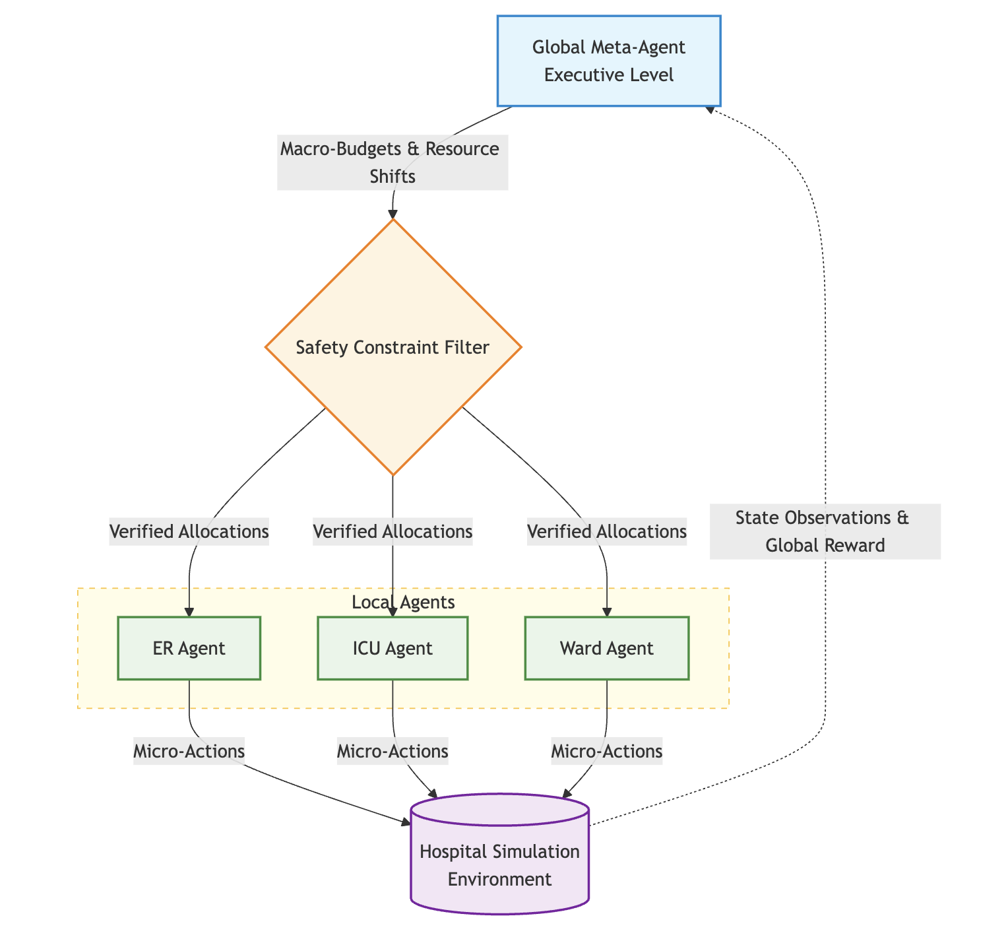
Fig. 1. The Proposed HC-MARL System Architecture Flow, demonstrating the feedback loop from the simulation environment back to the executive Meta-Agent.
B. Detailed Component Analysis
The system is driven by four primary components working in a continuous cycle:
- 1. Global Meta-Agent (Executive Level): Acting as the hospital's central nervous system, this agent operates on a macro time horizon (e.g., every 4 to 8 hours). By assessing the hospital's global state, its primary action is to output “Macro-Budgets & Resource Shifts”—dynamically moving flexible assets like floating nurses or budget caps to the departments that need them most.
- 2. Safety Constraint Filter (The Hard Constraint): Adapting the CMDP bounds established in safety-critical robotics [5], [6], this node acts as a strict fail-safe. Crucially, it evaluates only immediate, measurable state variables (e.g., ensuring a budget shift does not currently push the nurse-to-patient ratio beyond 1:6). If an allocation causes an immediate safety violation, the filter masks the action. Limitation Note: While this myopic evaluation prevents instantaneous clinical dangers, it does not currently forecast multi-step downstream violations (e.g., systemic collapse during later shift changes). Developing a predictive transition-model for this filter remains an area for future work.
- 3. Local Agents (ER, ICU, Ward): Operating within the boundaries of the “Verified Allocations,” these decentralized agents act as department heads managing micro-actions (triage, admission) every 15 minutes. Rather than employing direct peer-to-peer game-theoretic coupling—which can lead to unstable training—the Local Agents are coupled indirectly through the shared Simulation Environment and the Meta-Agent's finite budget, operating under a paradigm of hierarchical decentralized execution.
- 4. Hospital Simulation Environment: At the base is the simulation environment, representing the stochastic physics of patient flow. It processes localized micro-actions, transitions the hospital state, and calculates outcomes to transmit back as a “Global Reward.”
C. Mathematical Formulation for Equity (The Soft Penalty)
While clinical safety is treated as a hard constraint by the filter, demographic equity is enforced as a soft penalty in the global reward function:
R_{global} = Σ_{i} (αU_{i} − βW_{i}) − λΣ_{d} |𝔼[T_{d}] − 𝔼[T_{all}]| (1)
Where Ui represents resource utilization and Wi is aggregate wait time. Because utilization rates (percentages) and wait times (minutes) exist on entirely different scales, all variables are normalized to a [0, 1] range before applying the tunable coefficients α, β, and λ.
To ensure the equity term is computable, Td is explicitly defined as the moving average of wait times for demographic group d computed over a rolling 24-hour simulation window. Drawing from standard healthcare dataset conventions (e.g., NHAMCS-style data), we operationalize “equity” in this study primarily along the axis of insurance status (e.g., self-pay versus fully insured). The final term severely penalizes the model if the average wait time for any specific demographic (Td) deviates significantly from the global average wait time (Tall).
V. Evaluation Metrics and Baselines
Recognizing the ambition of a fully autonomous hierarchical MARL framework, the implementation is designed in two sequential phases. Phase 1 will disable the equity penalty (λ = 0) to validate hierarchical CMDP stability. Phase 2 will activate the equity penalty to determine if the hard safety limits and soft fairness penalties mathematically conflict during high-stress surges. The framework will be evaluated against uncoordinated single-agent baselines using the following success criteria:
- Throughput Efficiency: Total patient volume successfully discharged per 24-hour episode.
- Safety Violation Rate: The frequency at which the CMDP filter is forced to mask unsafe Meta-Agent proposals.
- Equity-Gap Magnitude: The maximum recorded variance in wait times across distinct insurance-status demographics.
- Convergence Speed: The number of training episodes required for the hierarchical agents to reach policy stability compared to flat MARL architectures.
References
[1] S. Lee and Y. H. Lee, “Improving Emergency Department Efficiency by Patient Scheduling Using Deep Reinforcement Learning,” Healthcare, vol. 8, no. 1, p. 77, Mar. 2020.
[2] P. Ribino, C. Di Napoli, and L. Serino, “A Multi-Agent RL Algorithm for Single-Day Operating Room Scheduling,” in Proceedings of the 25th European Conference on Artificial Intelligence, 2022.
[3] M. Lamiri, X. Xie, A. Dolgui, and F. Grimaud, “A stochastic model for operating room planning with elective and emergency demand for surgery,” European Journal of Operational Research, vol. 185, no. 3, pp. 1026–1037, 2008.
[4] T. A. O. Silva and M. C. de Souza, “Surgical scheduling under uncertainty by approximate dynamic programming,” Omega, vol. 95, p. 102066, 2020.
[5] P. Adjei, N. Tasfi, S. Gomez-Rosero, and M. A. M. Capretz, “Safe Reinforcement Learning for Arm Manipulation with Constrained Markov Decision Process,” Robotics, vol. 13, no. 4, p. 63, Apr. 2024.
[6] E. Altman, Constrained Markov Decision Processes, 1st ed. Chapman and Hall/CRC, 1999.

